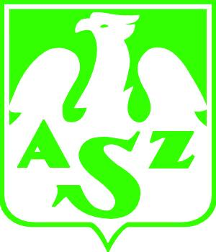 | Akademicki Związek Sportowy  Organizacja Środowiskowa w Łodzi  91 - 404 Łódź, ul. Lumumby 22/26  tel. (0-42) 677 10 10, fax 678 18 13,  e-mail: azslodz@poczta.onet.pl www.azs.pl  BP S.A. o/Komunalny w Łodzi 15201047-12638-27006-0000-0

Sekcja Badmintona
e-mail: badazsld@gmail.com www.badminton.p.lodz.pl
Łódź, 17.05.2013 r.
XX International BADMINTON Tournament “IBT - 2013” - INVITATION
1. Date and Place:
22.06.2013 (Saturday/Sunday)
AZS LODZ sport hall ul. Lumumby 22/26, Lodz

2. Members and Tournament System:
Matches best 2 sets to 21 points tournament system
men singles, women singles, men doubles, women doubles, mixed
there are no limitations – one player is allowed to play in 3 matches !!!
Explanation of the different categories:
A  B  C  D | National Club Players  Regional Club Players  Hobby Players  Beginners , Child U15
AB, CD categories
Tournament fee: 50zł (15€), Child U15 – 20zł (5€)
Shuttlecocks: Badminton feather shuttlecocks supplied by players
Awards: Diplomas, Cups and Medals.

3. Programme :
Friday 21.06.2013
19¹⁵ - 21⁰⁰ - arrival, registration
Saturday 22.06.2013
9⁰⁰ - 9³⁰ - warm up
9⁴⁵ - 9⁵⁵ - opening ceremony
10⁰⁰ - 17⁰⁰ - qualifications
17¹⁵ - 19⁰⁰ - finals matches
19¹⁵ - tournament decoration, closing ceremony
21⁰⁰ - dinner party, nightlife, fun
Sunday 23.06.2013
- check out, departure

4. TOURNAMENT INFORMATION: for your fun, yours sincerely
Grzegorz Michalowski – Tournament Manager, mobil (+48) 602 666 310, e-mail: migafmig@gmail.com
Tomasz Pyć – Contact person, mobil (+48) 604 199995, e-mail: tompyc@p.lodz.pl
https://www.facebook.com/events/657719860909728/

