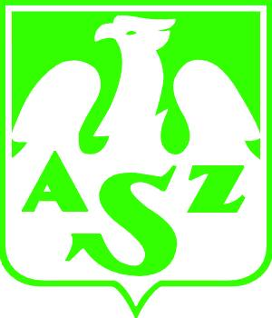 | Akademicki Związek Sportowy  Organizacja Środowiskowa w Łodzi  91 - 404 Łódź, ul. Lumumby 22/26  tel. (0-42) 677 10 10, fax 678 18 13,  e-mail: azslodz@poczta.onet.pl www.azs.pl  BP S.A. o/Komunalny w Łodzi 15201047-12638-27006-0000-0

Sekcja Badmintona
e-mail: bad-minton@wp.pl www.badminton.p.lodz.pl
Łódź, 7.07.2011 r.
International BADMINTON Tournament “IBT - 2011” - INVITATION
1. Date and Place:
22/23.10.2011 (Saturday/Sunday)
AZS LODZ sport hall ul. Lumumby 22/26, Lodz
2. Members and Tournament System:
Matches best 2 sets to 21 points tournament system
men singles, women singles, men doubles, women doubles, mixed
there are no limitations – one player is allowed to play in 3 matches !!!
Explanation of the different categories:
A  B  C  D | National Club Players  Regional Club Players  Hobby Players  Beginners
AB, CD categories
Tournament fee: 50zł (15€)
Shuttlecocks: Badminton feather shuttlecocks supplied by players
Awards: Diplomas, Cups and Medals.

3. Programme :
Friday 21.10.2011
19¹⁵ - 21⁰⁰ - arrival, registration
Saturday 22.10.2011
9⁰⁰ - 9³⁰ - warm up
9⁴⁵ - 9⁵⁵ - opening ceremony
10⁰⁰ - 15⁰⁰ - qualifications
15¹⁵ - 21⁰⁰ - ¼ finals matches
21³⁰ - dinner party, nightlife, fun
Sunday 23.10.2011
9³⁰ - 10⁰⁰ - warm up
10⁰⁰ - 12³⁰ - ½ finals matches
12³⁰ - 13³⁰ - CD finals
13³⁰ - 16⁰⁰ - AB finals
16¹⁵ - tournament decoration, closing ceremony
- check out, departure
4. TOURNAMENT INFORMATION: for your fun, yours sincerely
Grzegorz Michalowski – Tournament Manager, mobil (+48) 602 666 31, e-mail: bad-minton@wp.pl
Tomasz Pyć – Contact person, mobil (+48) 604 199995, e-mail: tompyc@p.lodz.pl

